Initial Assessment and Support Plan
- Participant Details:
Name:
NDIS number:
Plan Dates:
DOB: |  | Gender:
Address: |  | State:
Email Address: |  | Phone:
Preferred Contact Person:
- Preferred contact may include plan nominee/family member or other:
Name:
Relationship to participant:
Address:
Contact phone number:
Email Address:
Special Considerations:

- Provider Representative Details:
Service provider name:
Contact name:
Qualification:
Address: |  | State:
Email Address: |  | Phone:
Do you have any Preference for the Support workers’ gender? Male Female

- Alerts and Allergies
Please provide precise/ detailed information:
Allergies or Allergic to | Warning Signs & Symptoms | Immediate Action Required
- Participant’s Goals for this Assessment
Goal 1.

Goal 2.

Goal 3.

- Background and History
- Current Situation
- Strengths
- Challenges/Risks
- Things I like that make me happy
- Things I don’t like and make me sad; frustrated; angry; upset

- Risk assessment for participant
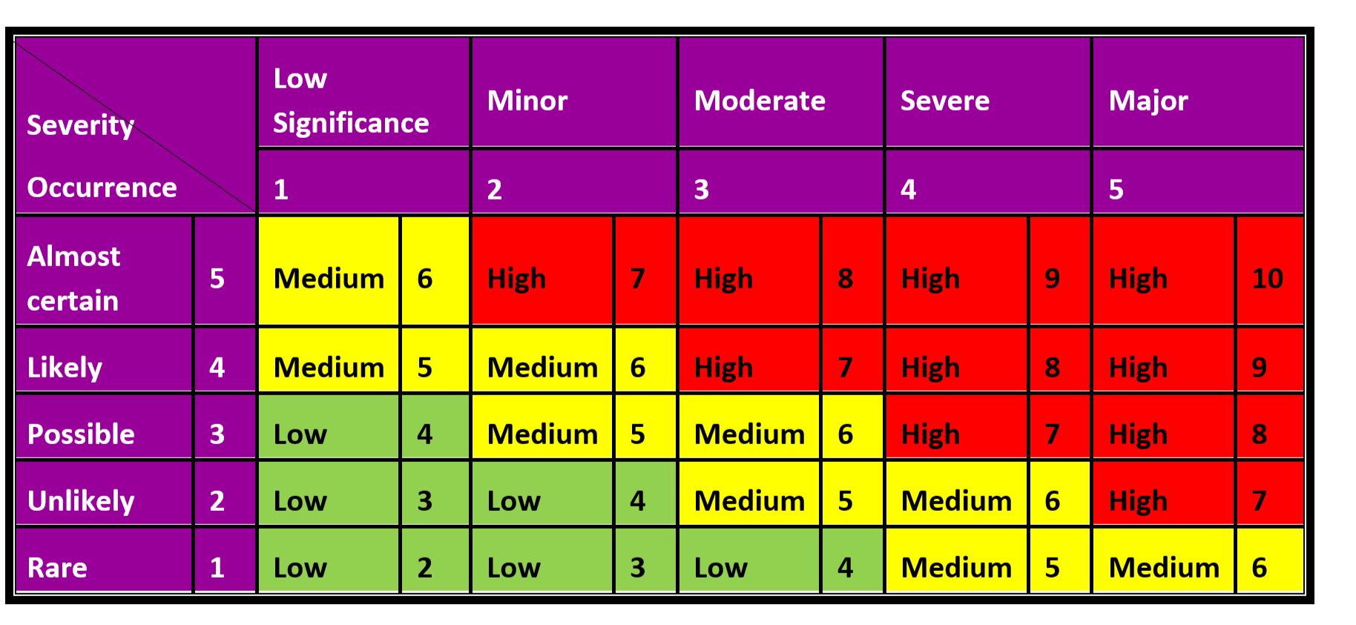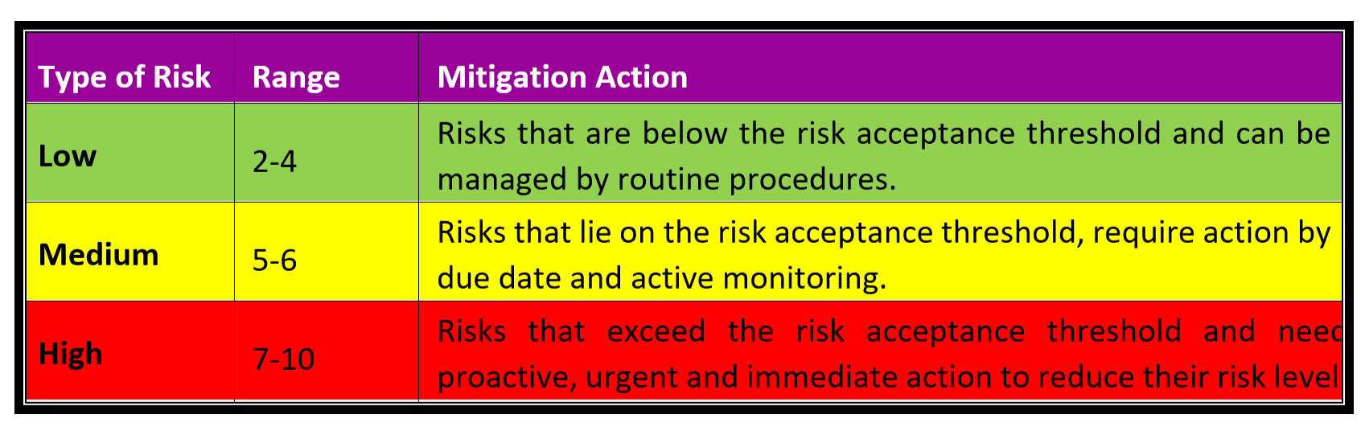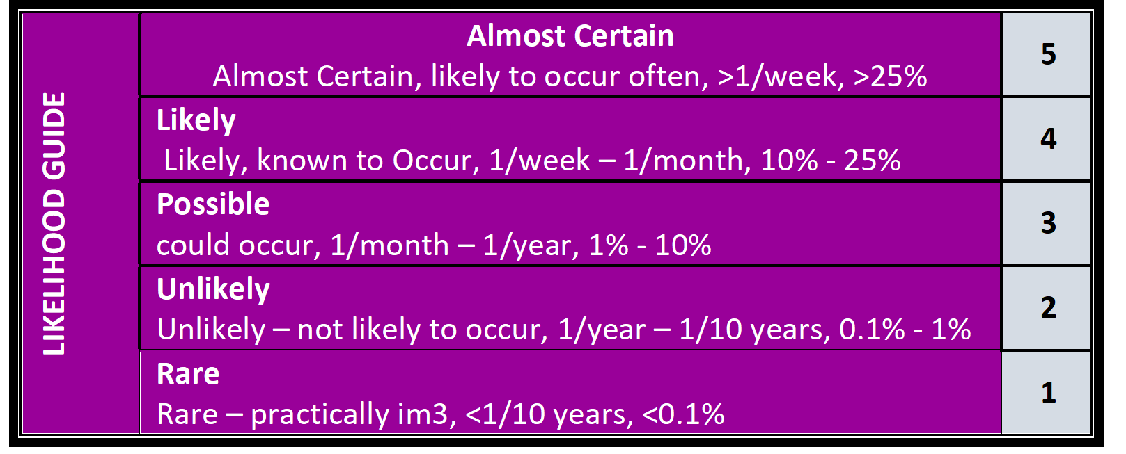

No. | Tasks or Activity | Issue/Hazard/Aspect | Risk/Impact | Consequence | Likelihood | RISK SCORE | Control Measures | Person Responsible | Residual Risks
 |  |  |  |  |  |  |  |  | Consequence | Likelihood | RISK SCORE
- Daily Activities
Day | Activity | Start | Finish | Details

Participant’s or Participant’s Representative’s Signature |  | Date
Author’s Signature |  | Date
Next revision date

